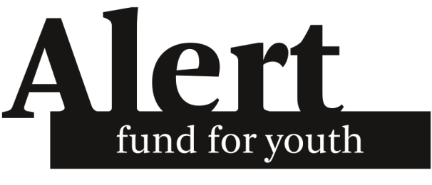
Alert Fund
www.alertfonds.nl
alert@alertfonds.nl

CRITERIA
Please read the following carefully before submitting your application.
Alert supports:
- Once-only and small-scale (inter-)national actions, protests and other activistic projects organised by (and for) young people, such as demonstrations, workshops, and publications
- Initiatives dealing with environmental issues, emancipation, political consciousness, international solidarity and multicultural co-existence
- You can apply for a maximum of €1500,-
- You cannot apply for actions which have a total budget larger than €15.000,-
- Alert does not fund travel costs, salaries or structural/organizational costs (for example rent or other monthly recurring costs)*
*unless you can explain why these are absolutely necessary for your project, and why you have no other way to raise these funds

Fast-track requests
If you are organising actions, protests or other activistic projects that will take effect on short notice and you think it is eligible for an Alert subsidy, you can submit a fast-track request. You can find the fast-track request application form at: https://alertfonds.nl/en/fast-track-request/. Within three weeks you will receive an answer. A fast-track request is only possible for subsidies up to €250,-.

Annexes
Optionally, you can send the following documents as annexes to this form. Keep in mind, however, that the complete budget is required in almost all cases (see budgetary information section for details).
- A complete budget (almost always required)
- A complete action plan
- The official regulations and/or registrations of the organization
- An annual budget of the organization
- An annual review of last year’s activities
- Other sources that mention your work/organization, for example newspaper clippings

Further procedure
Within three weeks after receiving this form you will be notified of the further procedure. Possibly, a board member will contact you either by email or phone when clarifications are needed. Normally you will be notified in writing about Alert’s decision within eight weeks.
You can send the filled-out form (with annexes) to: alert@alertfonds.nl

Contact info
In case you are applying on behalf of an organization:
Name of organization
Name of contact person
Address
Zip code & city
Country
Telephone number
E-mail
Website*
Registration number*
*If available
In case you are applying for yourself:
Name
Telephone number
Email
Website*
Country
*If available
Have you, or your organization, applied at Alert before?

How did you find out about Alert?

I hereby give permission to Alert Fund for Youth Foundation to process the personal data collected in this form for the purposes mentioned in Alert Fund's Privacy Statement, available on https://alertfonds.nl/en/request-subsidy/.
Yes ☐
No (please contact Alert Fund at office@alertfonds.nl) ☐

For verification, we ask you to provide a reference. The reference should be connected to an internationally known organization or a Dutch organization, or should be a Dutch person who is known by a board member of Alert. If your reference does not meet these criteria or you have no reference at all you can still apply, but it might negatively impact your chances.
Referent:
Name
Address
Zip code & city
Telephone number
E-mail address

Banking details
In case of an EU bank account:
A EU bank account is one that is part of SEPA, if you are not sure see here
IBAN number
Account holder name

In case of a non-EU bank account:
Use your actual account, not a reference bank
Account number
BIC / SWIFT code*
Account holder name
Account holder address (without place name)
Account holder place name

Any other banking information (like reference banks, or special comments):

The Action
Action title

What issue are you trying to address? (max. 150 words)

What concrete goals are you trying to reach? (max. 100 words)

What activities/actions will be organized to reach these goals? Use a maximum of 300 words. If you need more, add the full project description as an attachment and summarize the action here.
Who will be the participants, how many will there be, and how will you reach them? (max. 100 words)

Are there safety risks and how are you dealing with these possible risks?

When will the action start and finish?

Which of these themes does the project fit?

☐ Social, economic and political equality

☐ Climate and sustainability

☐ Anti-racism, feminism, and sexual rights

☐ Human rights

The organization
If applicable, please describe the organization. (max. 300 words)

Does your organization receive government support? If so, how much?

How are you a youth organization? (Age board, volunteers, etc.)

Budgetary information
How much money (in Euros) is needed for the entire action?

How much money (in Euros) are you applying to Alert Fund for?

We require a full budget for the entire action (not just the part you are applying at Alert for). A full budget should include all the sources of funding, and all the expenditures.
If your budget contains less than 5 items (including both incomes and expenditures), describe it below. If it contains more items, you are required to send the full budget as an annex.
An example budget can be found on our website here, feel free to use this format or an equivalent one.

